



# Incident Response Platform Integrations

# Cloud Foundry Function V1.0.0

Release Date: August 2018

Resilient Functions simplify development of integrations by wrapping each activity into an individual workflow component. These components can be easily installed, then used and combined in Resilient Platform workflows. The Resilient platform sends data to the function component that performs an activity then returns the results to the workflow. The results can be acted upon by scripts, rules, and workflow decision points to dynamically orchestrate the security incident response activities.

This guide describes the Cloud Foundry Function.

Overview

This function interfaces with Cloud Foundry platform to allow user to manage deployed applications, their instances, and deploy new applications. Managing the applications includes starting/stopping, updating, restaging, deleting, and getting various types of information about it. All of these possibilities are separated into 3 functions that can be used in the workflows.

It is a wrapper around Cloud Foundry’s API with possibilities to be adjusted for different platform providers. On the moment of release the latest stable version is: https://apidocs.cloudfoundry.org/3.1.0/

Installation

Before installing, verify that your environment meets the following prerequisites:

* Resilient platform is version 30 or later.
* You have the necessary credentials to access your provider’s Cloud Foundry API
* You have a Resilient account to use for the integrations. This can be any account that has the permission to view and modify administrator and customization settings, and read and update incidents. You need to know the account username and password.
* You have access to the command line of the Resilient appliance, which hosts the Resilient platform; or to a separate integration server where you will deploy and run the functions code. If using a separate integration server, you must install Python version 2.7.10 or later, or version 3.6 or later, and “pip”. (The Resilient appliance is preconfigured with a suitable version of Python.)

Install the Python components

The functions package contains Python components that are called by the Resilient platform to execute the functions during your workflows. These components run in the Resilient Circuits integration framework.

The package also includes Resilient customizations that will be imported into the platform later.

Complete the following steps to install the Python components:

1. Ensure that the environment is up-to-date, as follows:

sudo pip install --upgrade pip

sudo pip install --upgrade setuptools

sudo pip install --upgrade resilient-circuits

1. Run the following command to install the package:

sudo pip install --upgrade fn_cloud_foundry-1.0.0.tar.gz

Configure the Python components

The Resilient Circuits components run as an unprivileged user, typically named integration. If you do not already have an integration user configured on your appliance, create it now.

Complete the following steps to configure and run the integration:

1. Using sudo, switch to the integration user, as follows:

sudo su - integration

1. Use one of the following commands to create or update the resilient-circuits configuration file. Use –c for new environments or –u for existing environments.

resilient-circuits config -c

or

resilient-circuits config -u

1. Edit the resilient-circuits configuration file, as follows:
   1. In the [resilient] section, ensure that you provide all the information required to connect to the Resilient platform.
   2. In the [fn_cloud_foundry] section, edit the settings as follows:

[fn_cloud_foundry]

#Base url endpoint of your CF platform

#For example, for IBM’s BlueMix it is: https://api.stage1.ng.bluemix.net/

cf_api_base=xxx

#Enter only what’s required by your authenticator.

#For example, the default BlueMixCF authenticator only requires apikey.

cf_api_apikey=xxx

cf_api_username=xxx

cf_api_password=xxx

1. Current function is configured by default to work with BlueMix Cloud Foundry platform, but it can be connected to any platform that exposes API.
   1. Create a new **Authenticator** class, that inherits from **AuthenticatorBase** located in utils/authentication. It needs to implement 2 methods, auth – to authenticate, and get_headers – to return headers that need to be added to the http requests in order for it to be authenticated as a dictionary.
   2. In the code for the functions, the default authenticator will need to be replaced by the one you’ve created.
   3. Build the package with the new code, by running **python setup.py sdist**, and install the newly built package.

Deploy customizations to the Resilient platform

The package contains 3 functions that can be used in workflows, as well as an example workflow that demonstrates how to call one of the functions.

1. Use the following command to deploy these customizations to the Resilient platform:

resilient-circuits customize

1. Respond to the prompts to deploy functions, message destinations, workflows and rules.

Run the integration framework

To test the integration package before running it in a production environment, you must run the integration manually with the following command:

resilient-circuits run

The resilient-circuits command starts, loads its components, and continues to run until interrupted. If it stops immediately with an error message, check your configuration values and retry.

Configure Resilient Circuits for restart

For normal operation, Resilient Circuits must run continuously. The recommend way to do this is to configure it to automatically run at startup. On a Red Hat appliance, this is done using a systemd unit file such as the one below. You may need to change the paths to your working directory and app.config.

1. The unit file must be named resilient_circuits.service To create the file, enter the following command:

sudo vi /etc/systemd/system/resilient_circuits.service

1. Add the following contents to the file and change as necessary:

[Unit]  
Description=Resilient-Circuits Service  
After=resilient.service  
Requires=resilient.service

[Service]  
Type=simple  
User=integration  
WorkingDirectory=/home/integration  
ExecStart=/usr/local/bin/resilient-circuits run  
Restart=always  
TimeoutSec=10  
Environment=APP_CONFIG_FILE=/home/integration/.resilient/app.config  
Environment=APP_LOCK_FILE=/home/integration/.resilient/resilient_circuits.lock

[Install]  
WantedBy=multi-user.target

1. Ensure that the service unit file is correctly permissioned, as follows:

sudo chmod 664 /etc/systemd/system/resilient_circuits.service

1. Use the systemctl command to manually start, stop, restart and return status on the service:

sudo systemctl resilient_circuits [start|stop|restart|status]

You can view log files for systemd and the resilient-circuits service using the journalctl command, as follows:

sudo journalctl -u resilient_circuits --since "2 hours ago"

Function Descriptions

Once the function package deploys the function(s), you can view them in the Resilient platform Functions tab, as shown below. This package also includes an example workflow showing how to use one of the functions. You can edit and modify this workflow to your needs.

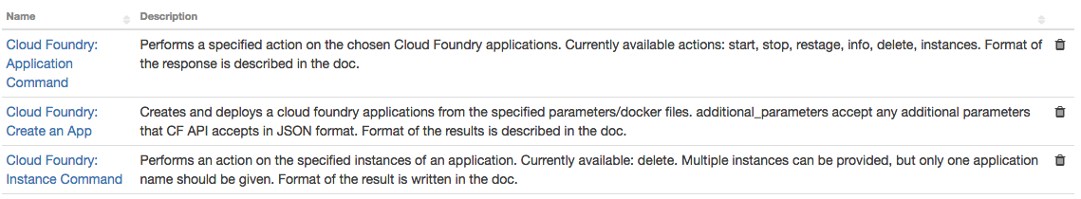

fn_cloud_foundry_manage_applications: Cloud Foundry: Application Command

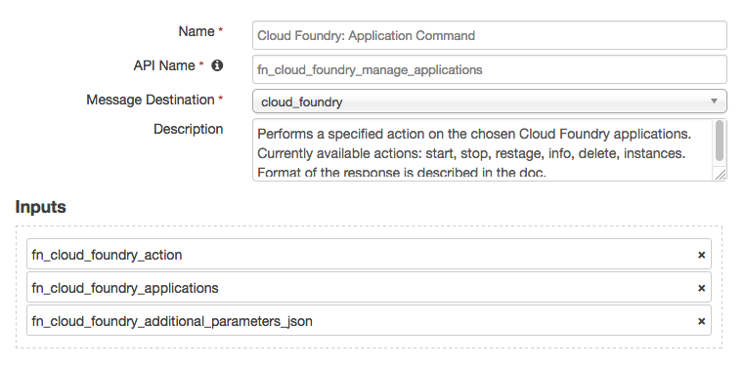

This function performs one of the chosen actions on the specified Cloud Foundry applications.

It takes in 3 inputs:

* fn_cloud_foundry_applications: **Required** – name or comma-separated names of the application(s) that the actions should be applied to.
* fn_cloud_foundry_action: **Required** – select field with the list of all possible actions to be performed on the application. They include start, stop, restage, delete, instances, and info.
* fn_cloud_foundry_additional_parameters_json: **Optional** – here for the purposes of allowing the actions to be added and extended in the future. Accepts valid JSON, which will be passed to the method executing chosen actions.

Listed below, is the format of the results that the function produces. It would list whether the action was successfully applied to each of the applications specified, as well as other data relevant to the action itself, per application.

{

"application-1": {

"success":true,

"other_data": "...",

"_keys": ["success","other_data"]

},

"application-2": {

"success":false,

"details ": "...",

"_keys": ["success","details"]

},

"_keys": ["application-1", "application-2"]

}

OR, if the action is incorrect:

{

"success":false,

"details": "...",

"_keys": ["success","details"]

}

“_keys” store the list of keys for each level of a dictionary to provide convenience in post-processing.

fn_cloud_foundry_create_app: Cloud Foundry: Create an App

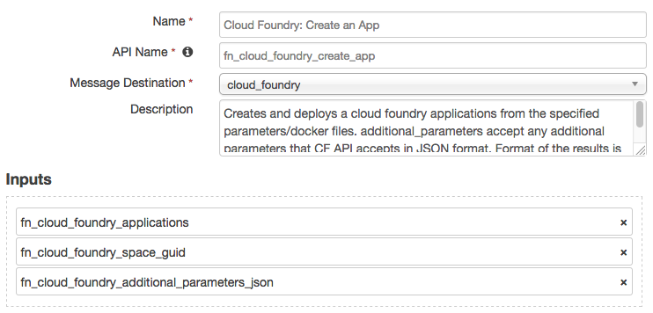

This function creates a new application in Cloud Foundry’s platform.

It takes in 3 inputs:

* fn_cloud_foundry_applications: **Required** – single name of the app to be created.
* fn_cloud_foundry_space_guid: **Required** – GUID of the space in which the app should be created.
* fn_cloud_foundry_additional_parameters_json: **Optional** –Accepts valid JSON, which will be passed to the method executing chosen actions.

Can be used to specify the fields needed for the creation of the **Docker** application, as stated in the API.

Return value will contain the information about the app, as provided in the API as well as “success” field to determine whether the app was, in fact, created.

fn_cloud_foundry_instance_command: Cloud Foundry: Instance Command

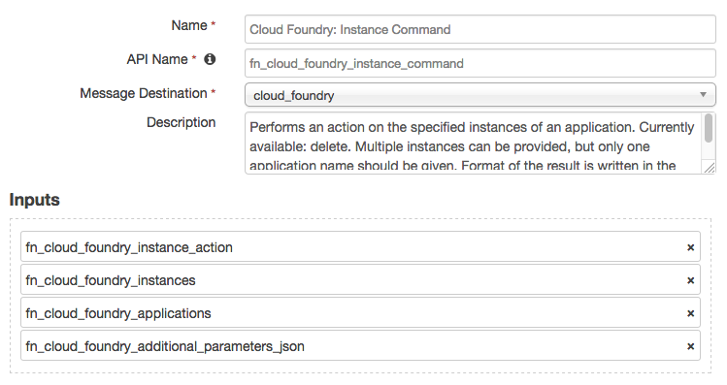

Function that perform commands on the instances of a specified application. Currently only supports deleting an instance.

It takes in 4 inputs:

* fn_cloud_foundry_instances: **Required** – name or comma-separated names of the instances(s) that the actions should be applied to.
* fn_cloud_foundry_applications: **Required** – name of the single application whose instances should be affected by the action.
* fn_cloud_foundry_instance_action: **Required** – select field with the list of all possible actions to be performed on the instance. Currently, only delete.
* fn_cloud_foundry_additional_parameters_json: **Optional** – here for the purposes of allowing the actions to be added and extended in the future. Accepts valid JSON, which will be passed to the method executing chosen actions.

Troubleshooting

There are several ways to verify the successful operation of a function.

* Resilient Action Status

When viewing an incident, use the Actions menu to view Action Status. By default, pending and errors are displayed. Modify the filter for actions to also show Completed actions. Clicking on an action displays additional information on the progress made or what error occurred.

* Resilient Scripting Log

A separate log file is available to review scripting errors. This is useful when issues occur in the pre-processing or post-processing scripts. The default location for this log file is: /var/log/resilient-scripting/resilient-scripting.log.

* Resilient Logs

By default, Resilient logs are retained at /usr/share/co3/logs. The client.log may contain additional information regarding the execution of functions.

* Resilient-Circuits

The log is controlled in the .resilient/app.config file under the section [resilient] and the property logdir. The default file name is app.log. Each function will create progress information. Failures will show up as errors and may contain python trace statements.

Support

For additional support, contact [support@resilientsystems.com](mailto:support@resilientsystems.com).

Including relevant information from the log files will help us resolve your issue.